Lab 8 Stellar Spectra

Goals
- Learn how stars are classified ( O B A F G K M ) and what these types represent about temperature
- Examine the relationship between temperature of an object and the spectrum it produces
- Examine 8 real stellar spectra and determine the spectral type of the stars

Resources
PhET Thermal spectrum simulation https://phet.colorado.edu/en/simulation/blackbody-spectrum
The Astrophysics Data System (ADS) http://adsabs.harvard.edu/abstract_service.html

Background Knowledge
Recall that there are three types of spectra: Thermal (continuous), emission line, and absorption line. Here we will focus on the thermal spectrum from stars which also contain absorption lines. The overall shape of the spectrum will tell you about the temperature, and the absorption lines will tell you about the chemical composition and ionization state of the outer layers of the star’s atmosphere. The combination of absorption lines and temperature provide a way to classify stars based on their temperature.

Spectral Type | Temperature range [K] | Absorption lines
O | Hotter than 30,000 | He+, O++, N++, Si++, He, H
B | 30,000 – 10,000 | He, H, O+, C+, N+, Si+
A | 10,000 – 7,500 | H (strongest), Ca+, Mg+, Fe+
F | 7,500 – 6,000 | H, Ca+, ionized metals
G | 6,000 – 5,000 | H, Ca+, ionized and neutral metals
K | 5,000 – 3,500 | H (weak), Ca+ (strongest), neutral metals
M | Cooler than 3500 | Neutral metals, TiO, molecules

(Note: Each Spectral Type is subdivided from 0-9 as well. E.g. the Sun is a G2 spectral type.
... F0, F1, F2, ….,F8, F9, G0, G1, G2, G3, G4, G5, G6, G7, G8, G9, K0, K1, K2….. etc… )

Part 1 : Temperature and peak wavelength of emission

Think About It
A blackbody is a solid or a very dense gas. In the case of a traditional light bulb, the blackbody is the filament, a solid. As you increase the power to the light bulb, what happens to the temperature of the filament? What happened to the color of the filament? What is the relationship between the temperature of the filament and the wavelength of the color of the filament?

Work On It
Use a spectrograph or grating slide to observe a light bulb connected to a variable power source. Vary the power going from lowest 1.0V to highest 8V and record what you see in the spectrograph.

Think About It
When the bulb was receiving the lowest power, was there blue light? When the bulb was receiving the highest power, was there red light? Did the spectrum you observed change as you changed the power going to the light bulb? How did it change, if it did? If it didn’t change, why do you think it did not change? Do your best to explain your observations based on what you know. Check your explanations with your instructor.

Work on it
Use the blackbody radiation simulation found at the PhET website in the resources.
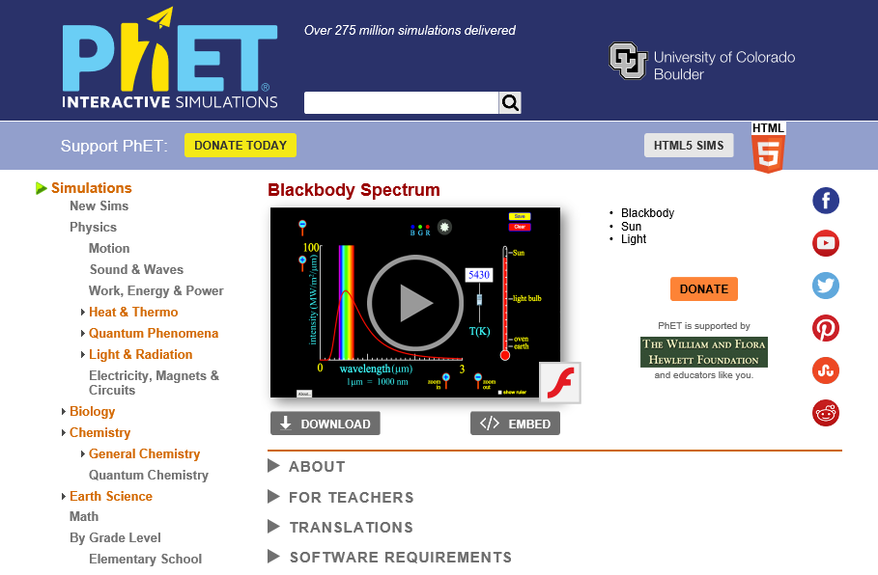

The red curve represents the thermal spectrum produced by an object of the given temperature. Vary the temperature from a low of 3,000K to a high of 9,255K. Note the relative height of the curve and the position of the peak, where the most light comes out.

Temperature [K] | Relative height of curve | Peak wavelength
3000
4000
5000
6000
9255
(Note, you may need to change the scale of the vertical axis if the peak goes off the chart.)
You should find that as temperature increases, the overall amount of emission increases, and the peak moves to shorter wavelengths. The relationship between temperature, T, and the peak wavelength of emission, λ_{max} , is given by Wein’s Law as follows.

$$T= \frac{2.9×{10}^{6} nm K}{λ_{max}}$$

This relationship makes it possible to observe a spectrum, measure the peak wavelength of emission in units of nanometers, and then calculate the temperature of the object in Kelvin (no thermometer needed).

PART 2: Identifying stellar spectra

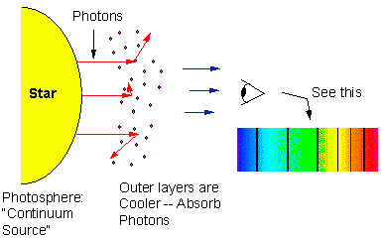
Think About It
Why do stars produce absorption line spectra? The interior of the star is very hot and dense, so it produces a continuous thermal spectrum. The outer layers of the star’s atmosphere are much lower density gas which the continuous light must pass through to reach us.

A stellar spectrum can be useful both to learn about the elements in the stars as well as its temperature. You can see below that a comparison of an ideal thermal spectrum to an actual absorption line spectrum from a star are very similar to each other. The overall shape of the spectrum can still be used to estimate λ_{max} and thus determine the temperature of the star.

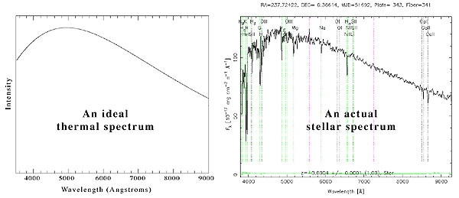

Understanding the details of absorption lines in stellar spectra can be quite complex, so we will use several comparison spectra to help identify the stellar spectra at the end of the lab. The Astrophysics Data System (ADS) is a resource that houses electronically scanned refereed publications in astronomy (http://adsabs.harvard.edu/abstract_service.html), where you can download and save or print out comparison spectra. Find the article written by Jacoby, Hunter and Christian in 1984, published in the Astrophysical Journal Supplement (ApJS). You can do this by typing in “Jacoby”, “Hunter” and “Christian” in the box under “Authors” and “1984” in the “Publication Date” box, then “Send Query”. The article is titled “A Library of Stellar Spectra.” To view the article, click on the “F” to view a .pdf file, which you should be able to page through and print. The spectra that you are interested in begin on page 259 of this article.

Work On It

Examine the 8 stellar spectra at the end of this lab. Use what you know about Wein’s law to determine the temperature of the stars (or place limits on it). Compare the spectra to the reference spectra from the article and examine their absorption line features. Try to identify the Spectral type as accurately as you can. Your response will be correct as long as it is within ± 5 subdivisions of type. E.g. Star X has a peak wavelength of 500nm and a spectral type G2, so a response of F7 or G7 would still be correct for Star X, but K0 would be clearly wrong.

For each star be sure to record your measured peak wavelength, computed temperature, and identify the Spectral Type.
(To check yourself, the actual stellar spectra above has a peak wavelength around 460nm, a temperature around 6,300K, and estimated spectral type is F8)

Lab Report Requirements
Imagine you are working at an observatory and your advisor gives you 8 spectra and says I need you to figure out the spectral types of these stars and give me a write up of your results.

Introduction: Explain the Stellar Spectral Types and what they represent about the physical properties of a star. Explain what Wein’s law represents and how it is useful for your goal of identifying spectral types.

Method: Describe how you will attempt to identify the spectral types of the stars. E.g. What are you looking at in the graphs, what computations you will use, and what comparisons you will make.

Data: For each of the 8 stars report λ_{max} (or a limit) and the computed temperature (or limit). (Also identify if any spectral features were useful to identify the specific spectral type.)

Conclusion: Conclude with your estimate of the spectral type for each star.

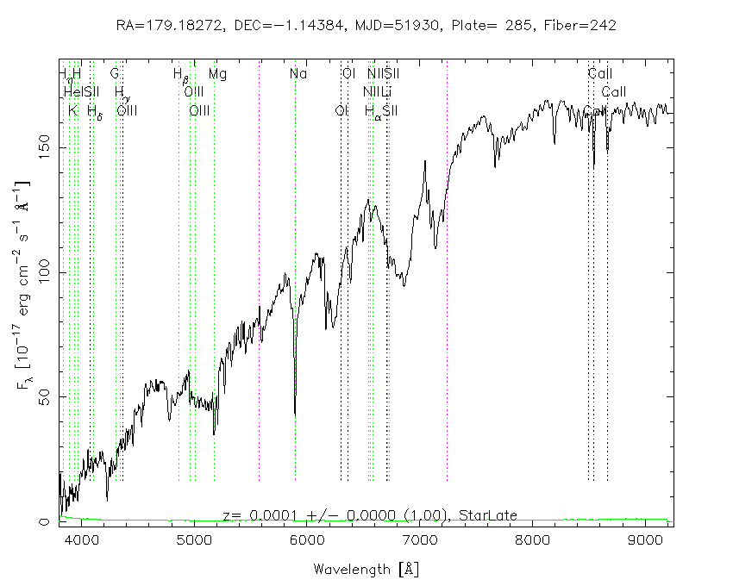
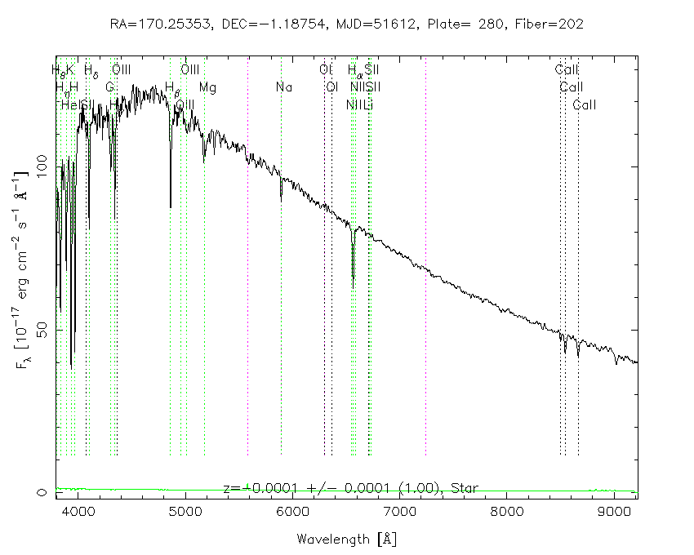
ASTRONOMY LAB: Stellar Spectra Identification
Star 1 Star 2
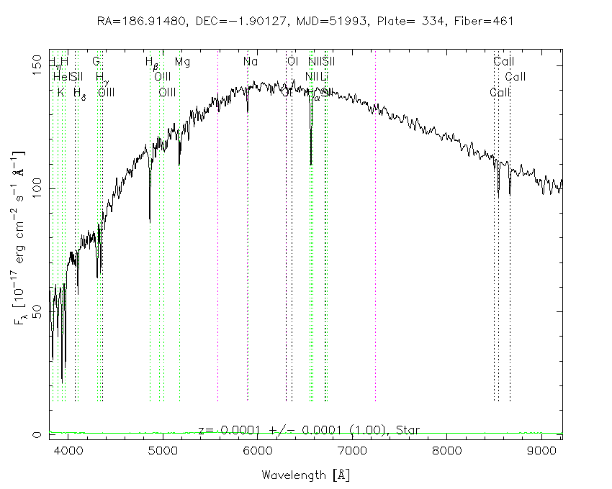
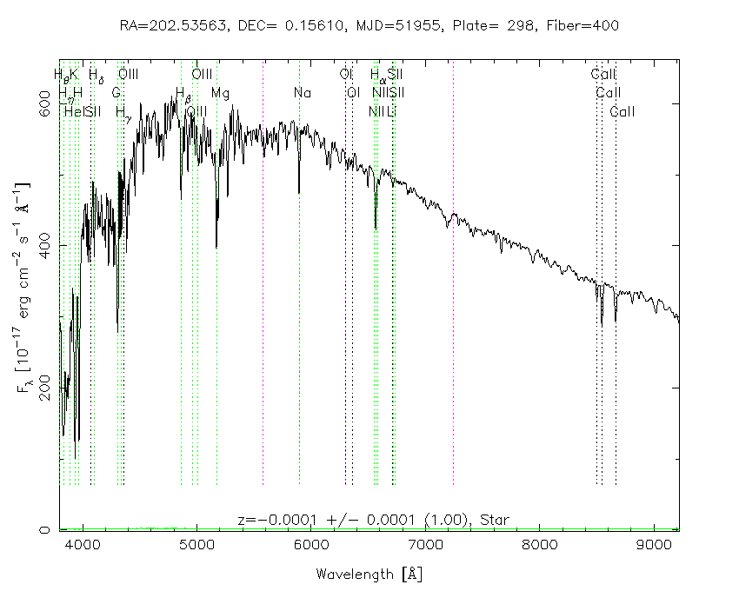
Star 3 Star 4

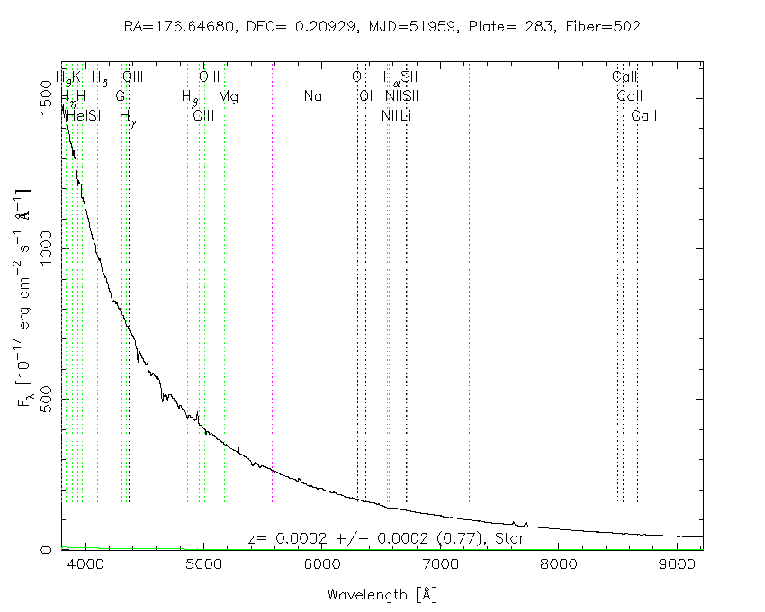
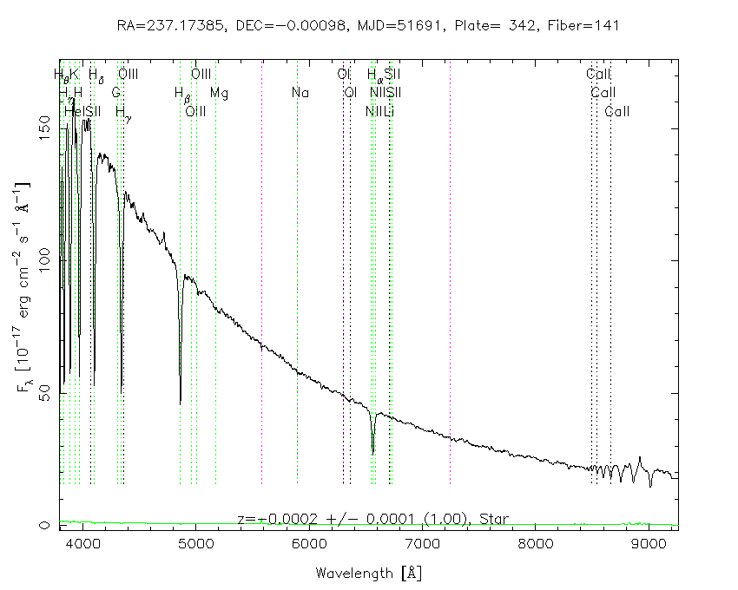
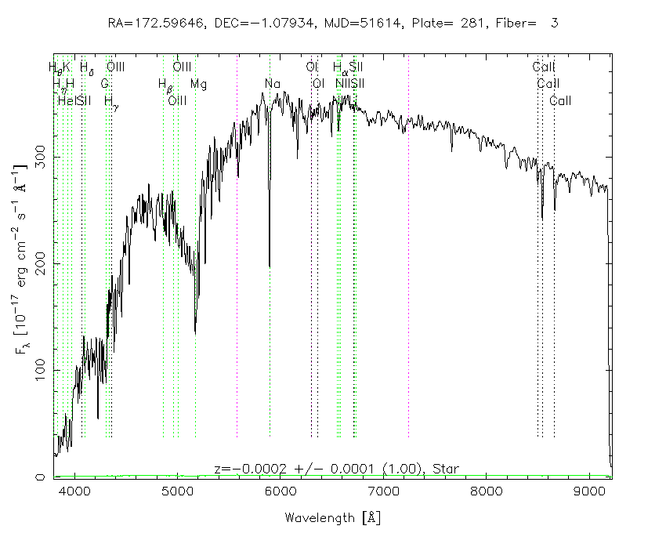
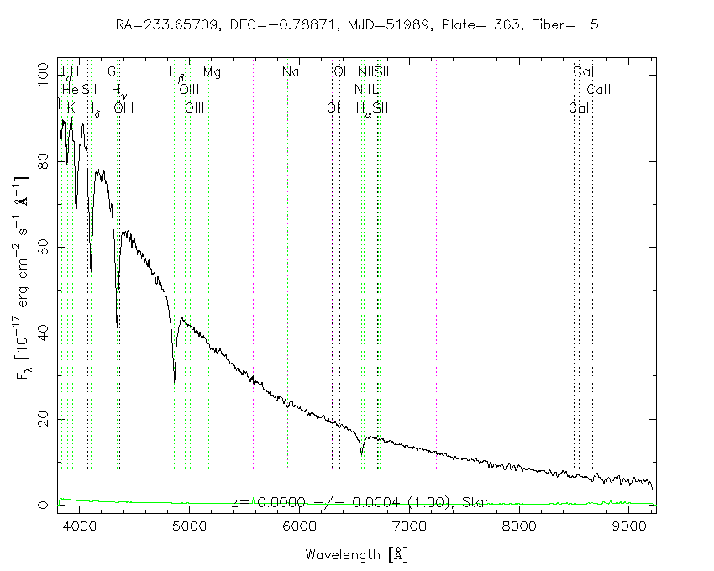
Star 5 Star 6
Star 7 Star 8

